LAWATAN EXTERNAL EXAMINER PROGRAM DEE & DEP
𝟮𝟯-𝟮𝟰 𝗙𝗘𝗕𝗥𝗨𝗔𝗥𝗜 𝟮𝟬𝟮𝟭 (𝗦𝗘𝗟𝗔𝗦𝗔-𝗥𝗔𝗕𝗨)

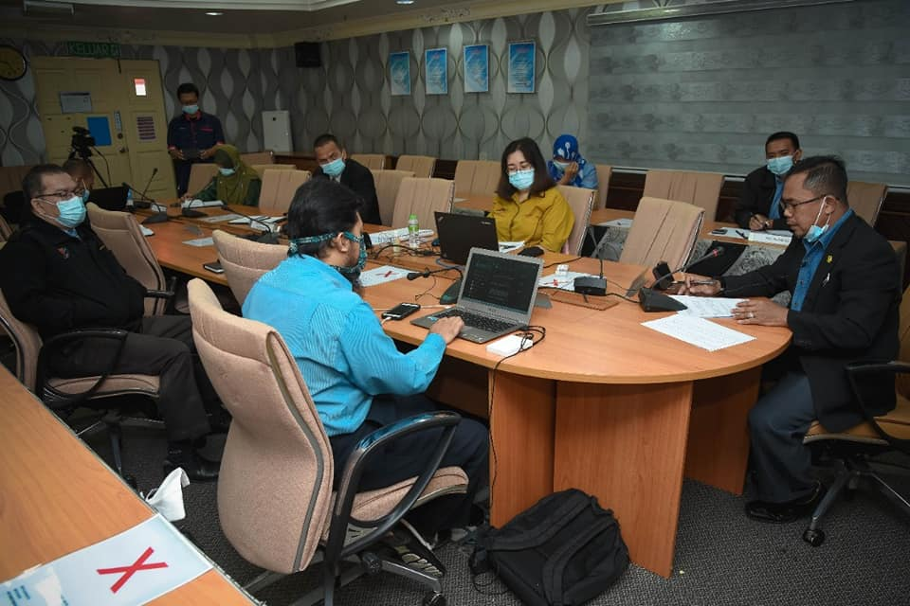
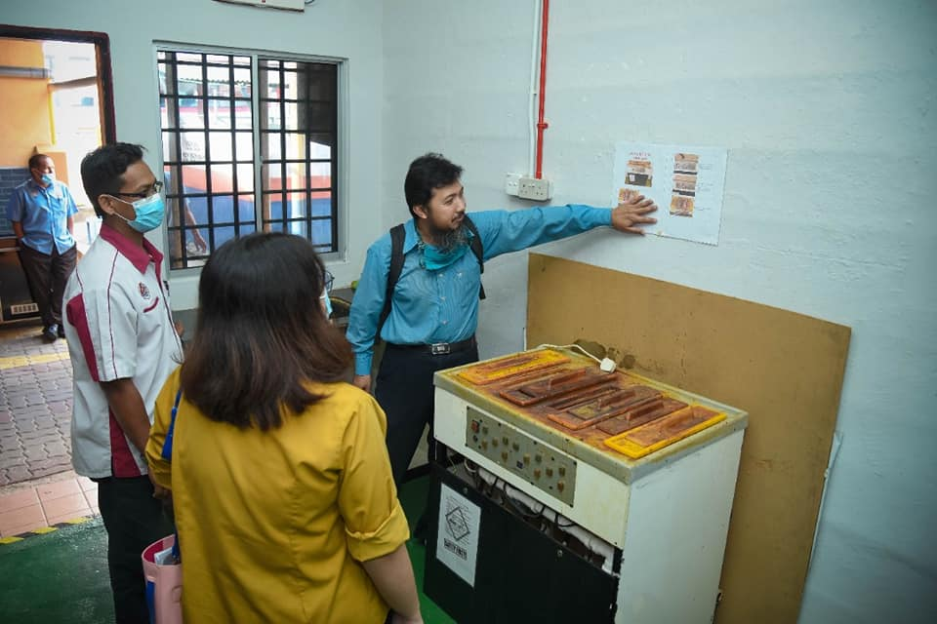

PROGRAM MENTOR MENTEE FYP DENGAN ALUMNI SERTA INDUSTRI
19 APRIL 2021

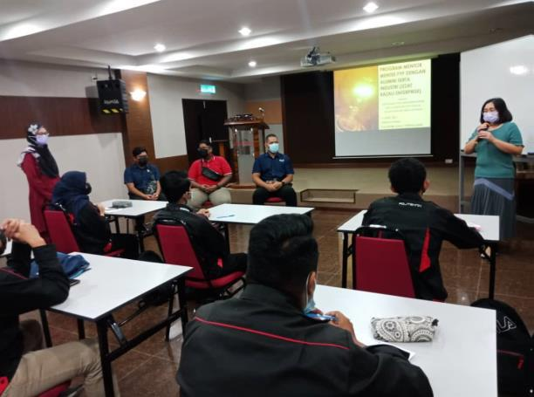
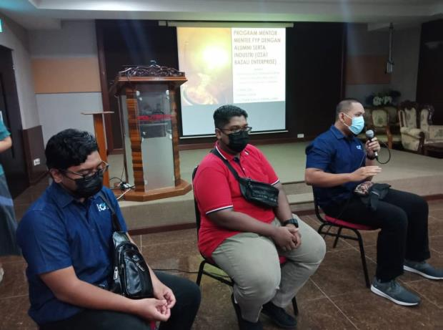

SEMINAR INNOVATION TECHNOLOGY IN ELECTRICAL DEPARTMENT (iTED) 1/2021
16 JUN 2021

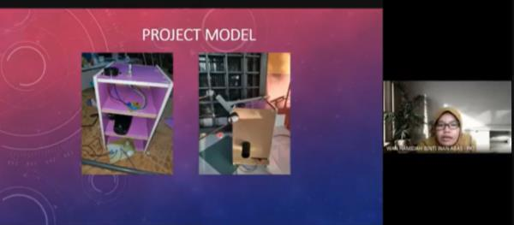

𝗞𝘂𝗿𝘀𝘂𝘀 𝗣𝗲𝗺𝗮𝗻𝘁𝗮𝗽𝗮𝗻 𝗣𝗲𝗺𝗮𝗵𝗮𝗺𝗮𝗻 𝗢𝗕𝗘 𝗣𝗲𝗹𝗮𝗷𝗮𝗿
5 OGOS 2021
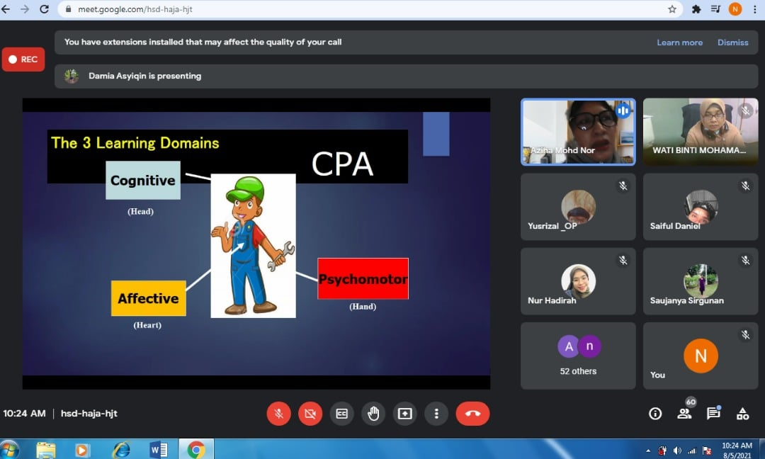

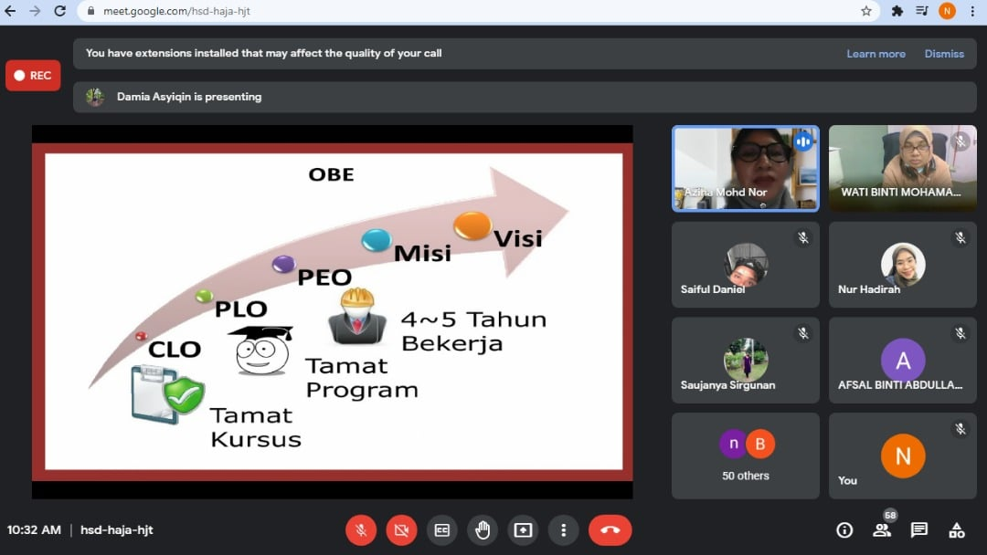

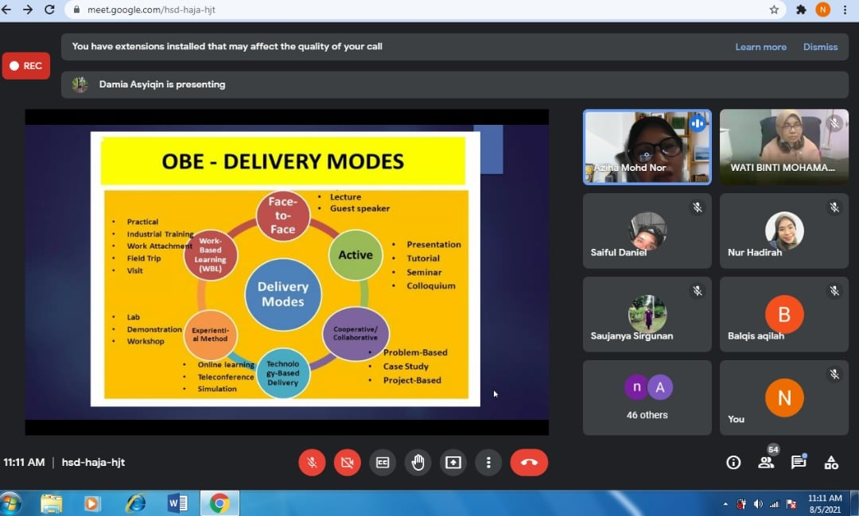

𝗞𝗨𝗥𝗦𝗨𝗦 𝗠𝗔𝗣𝗣𝗜𝗡𝗚 𝗢𝗙 𝗗𝗘𝗘’𝗦 & 𝗗𝗘𝗣’𝗦 𝗖𝗢𝗨𝗥𝗦𝗘𝗦 𝗧𝗢 𝗧𝗛𝗘 𝗘𝗧𝗔𝗖 𝗞𝗡𝗢𝗪𝗟𝗘𝗗𝗚𝗘 𝗣𝗥𝗢𝗙𝗜𝗟𝗘 (𝗗𝗞), 𝗪𝗘𝗟𝗟- 𝗗𝗘𝗙𝗜𝗡𝗘𝗗 𝗣𝗥𝗢𝗕𝗟𝗘𝗠 𝗦𝗢𝗟𝗩𝗜𝗡𝗚 (𝗗𝗣) 𝗔𝗡𝗗 𝗪𝗘𝗟𝗟-𝗗𝗘𝗙𝗜𝗡𝗘𝗗 𝗘𝗡𝗚𝗜𝗡𝗘𝗘𝗥𝗜𝗡𝗚 𝗔𝗖𝗧𝗜𝗩𝗜𝗧𝗜𝗘𝗦 (𝗡𝗔)
7 hingga 8 SEPTEMBER 2021

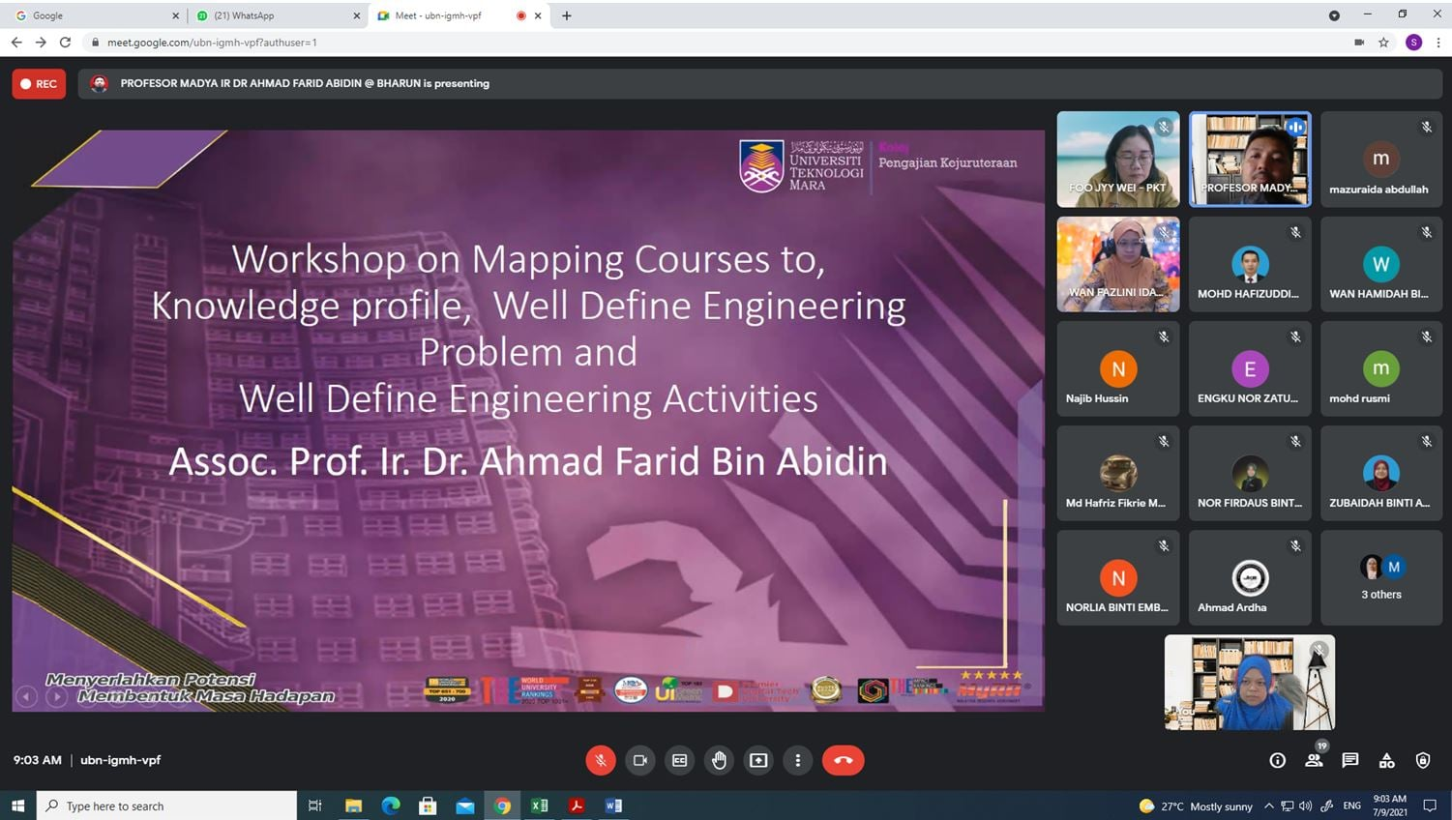
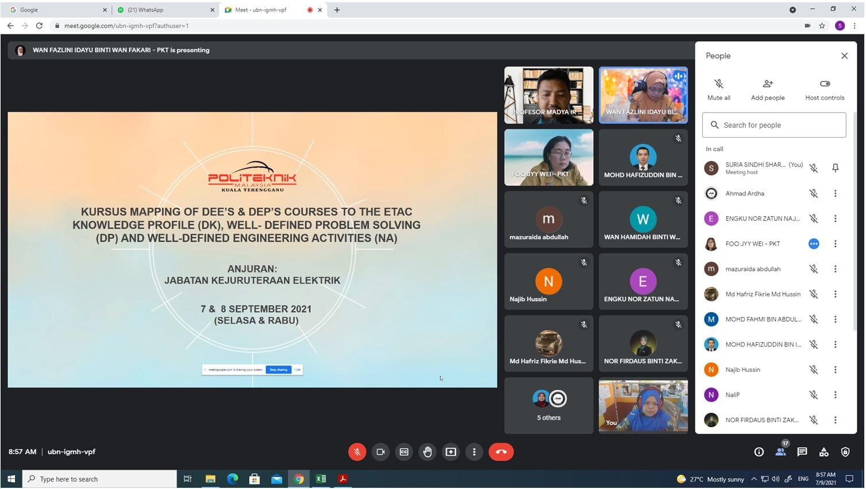

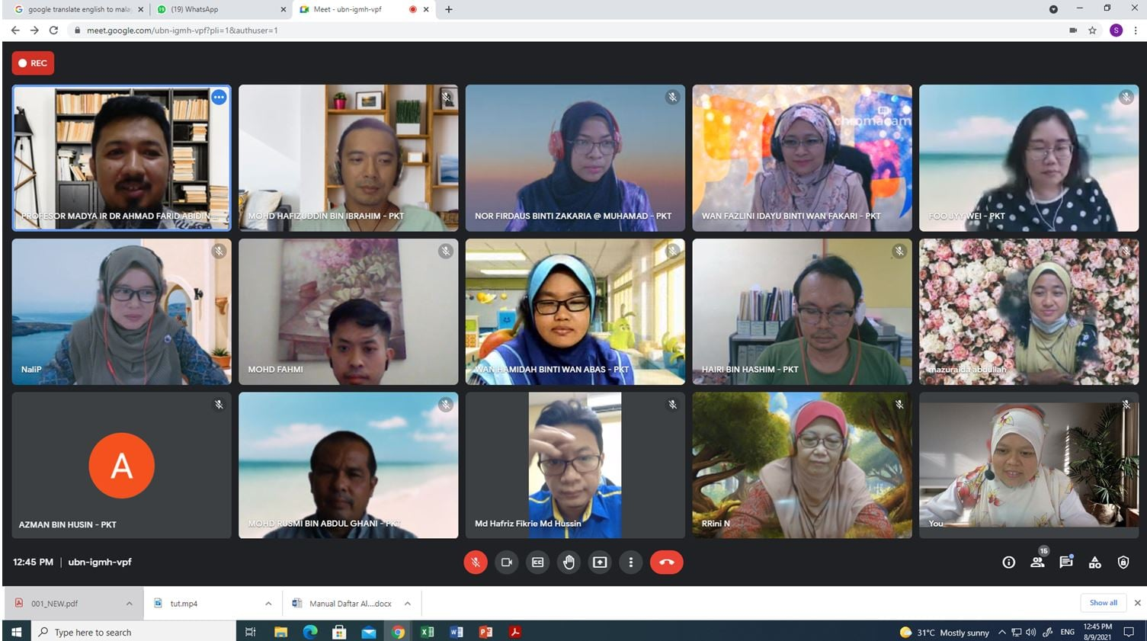

WEBINAR PROJECT MANAGEMENT & FINANCE
14 SEPTEMBER 2021
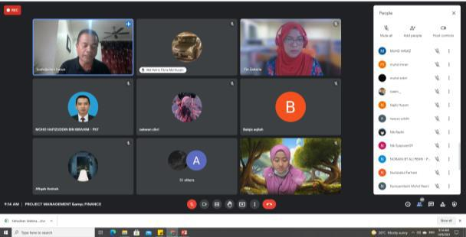

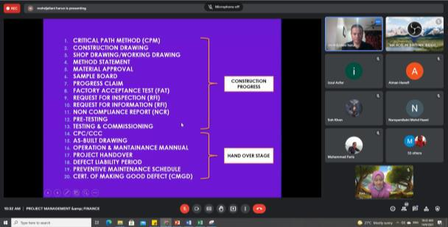

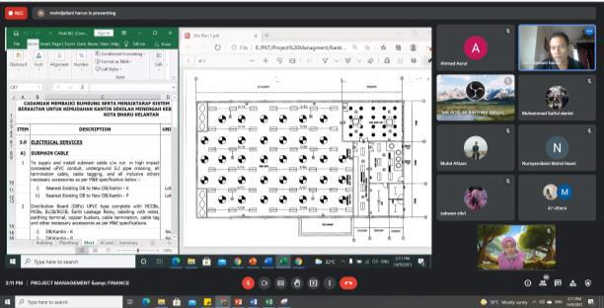

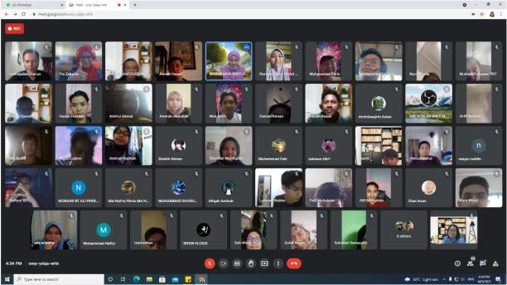
FESTIVAL OF IDEAS: i- Notifier System
14 SEPTEMBER 2021
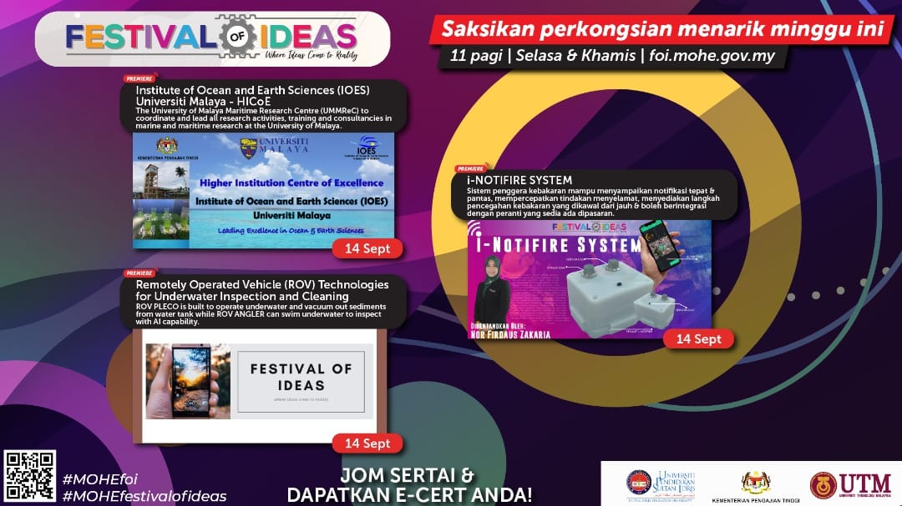

CAREER TALK JKE – 2: RADIO FREQUENCY IDENTIFICATION (RFID)
27 SEPTEMBER 2021
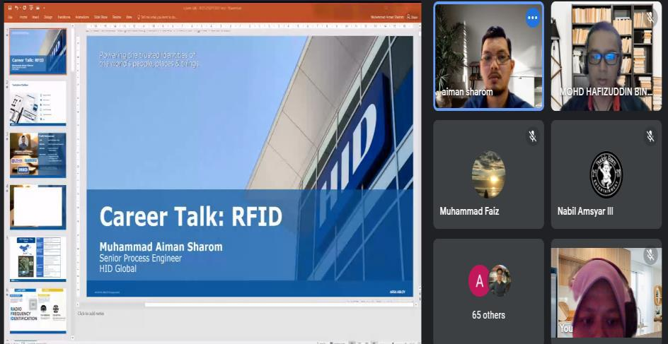

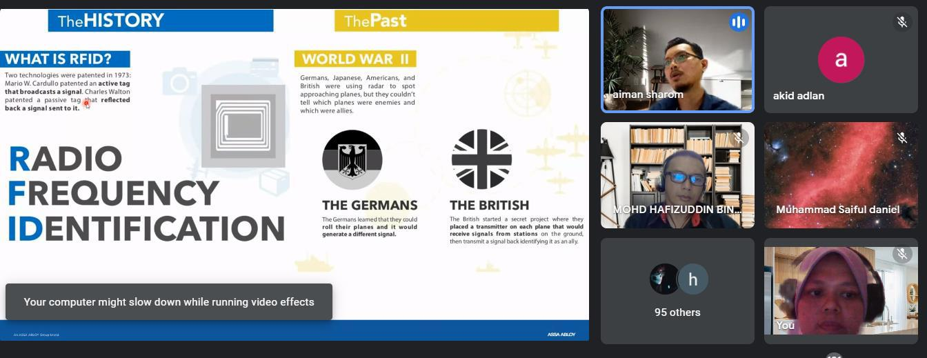

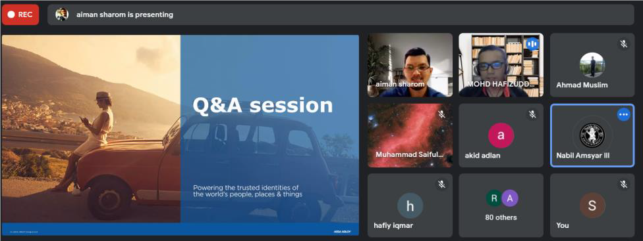

CAREER TALK JKE – 3: ELECTRICAL ENGINEERING CAREER PATHS
27 SEPTEMBER 2021
